Chapter 1 - Introduction

  - Overview of the System

Customer Relationship Management System

The system is a web based Manufacturing System that enables a Manufacturing company to schedule its manufacturing operations based on the daily update of sales from its dealers. The system is modeled to be used by a Manufacturing company, whose main activity is manufacturing different products & then selling the finished goods through a network of Dealers.

To start with, the Stocks of all the Products manufactured by the company and held in the company ware-house are stored in a Database. The details that are stored include the quantity of each product held with the company dealers who hold the stocks of finished products for sale.

Once the sales figures of Products sold in the past week are entered by the Dealers over the internet along with the Orders for the next delivery, the schedule for the next week’s production will be drawn up. A report of the required raw materials or parts will be drawn up with the approved suppliers for each & the suppliers will be intimated about the part requirements over the internet & asked to quote their rates. The message asking for a Quotation will be sent as an e-mail message. Once the rates are quoted, the Order will be placed with the required delivery schedules.

The system incorporates intelligent Order processing System which checks and intimates the required Higher-ups in the Company about any discrepancies in the Orders that were placed. For example if an Order is placed with a Supplier whose rates are not the least then an automatic Event-generation will send the details of the Order & the person who placed it to the Managers or Directors who are supposed to oversee the process.

Once the parts are supplied the Part Stocks will be updated. Then a production plan will be drawn up taking the Bill-of-materials into consideration. The Bill-of-Materials contains the details of each Product & the type & quantity of Parts required for manufacturing a single unit of the Product. Once the Production plan is approved, the Part Stocks will be updated when the Parts are issued to the Production Department. Once the finished products are available from the Production Department, the Products will be dispatched based on the Orders placed by the Dealers. The stocks with the dealers will also be maintained.

1.2 Business Requirements Analysis is a Manufacturing company, which manufactures different models of Computers & sells them through a network of Dealers. The company stores details for each model. The different models will henceforth be referred to as Products. The details that are stored for each product are Name, description, Price & Status.

The company has a network of Dealers who sell the Products manufactured by the company. The company holds details of all their Dealers like the Dealer Name, Address, Credit limit & status – which can be active or inactive.

The company has a warehouse, which stores all the Product Stocks – the finished goods that have been manufactured & are ready for dispatch to Dealers. Dealers also hold Product Stocks in their Sales out-lets.

The Dealers submit their sales figures & place orders for new Stocks of products at the end of each week. They take into consideration the sales figures when they order for new stocks. The Order placed will sometimes be the same as the sales figure. It may also be different.

Once Dealers place the Orders, a Production Schedule Report will be generated. This report is based on the total Orders placed & the current Product Stocks held with the company. The final Production Schedule is generated by removing the Product Stocks above the re-order level present with the company in its warehouse, from the total Orders placed for the Products by the Dealers.

When the Production Schedule is ready, a Parts Indent (requirement of the raw materials to manufacture the Products Ordered) will be generated from the Bill-of-Materials. The Bill-of-Materials is a list, which contains the details of parts & the quantity of each required for manufacturing a given Product. Each Product has a corresponding Bill-of-Materials.

The Parts indent is generated, by taking into account, the Production Schedule, the Bill-of-Materials & the Stocks of parts already held with the company in its stores. The final Parts indent is arrived at by removing the Part Stocks above the re-order level held in the company stores from the total number of parts required for manufacturing the Products in the Production schedule.

Once the Parts indent is generated, the Suppliers are intimated about the requirement of Parts. To enable this, the details of the Suppliers like their name, address, e-mail address, Telephone number, status are held with the company.

The Suppliers quote the rates once they receive intimation about the requirements. The company’s procurement department staff then look at the quotations submitted & confirm procurement orders for the supply of Parts. The Managerial staff review the Orders thus confirmed, to check that quotations placed are for the lowest rates.

When their quotation is accepted & the order confirmed, the Suppliers supply the Parts. When Parts are delivered by the Suppliers, to the Stores, the Part Stocks held in the company Stores are updated.

These Part Stocks are then delivered to the Production Department when the manufacturing starts. These Part Stocks are then updated by removing the figure dispatched to the Production department form the Stocks held with the stores.

After Production is completed, the production department sends the finished Products to the warehouse where the Product Stocks are held. The figure of Products stocks thus received will be added to the Product Stocks held in the company warehouse.

Once the Product Stocks are available these will be dispatched to the Dealers who placed Orders for them. The Product stocks held with the company will be reduced by the amount dispatched & the Dealer’s Stocks will be increased by the same amount.

Thus the cycle is repeated for every week. Currently all the above activities are done manually. The process is a tedious one. To arrive at the production Schedule or Order Indent for Parts, data has to be gathered from various sources. Because of this errors are occurring in the process, which is leading to delayed deliveries to the Dealers. Some times because of the errors wrong products are produced which have no requirement & thus a lot of money is being wasted in maintaining the inventory.

Automating such a process will not only eliminate the errors in the process, but also bring down the delivery times & make the company more competitive. So it was decided that an automated system should be developed to make the whole process simpler & easier.

The following is the system developed for the above stated needs. An initial feasibility study was performed & a conclusion was arrived at that automating such a system will not only achieve all the things mentioned above, but will also provide additional Reports which will enable the Management to look at the statistical side of the Sales & predict future sales trends or demand for products. This would also create a Stock inventory system, which would reduce the inventory levels with the company, thus effectively reducing the borrowing costs of the company. Another advantage was that the whole Accounts system could be linked to this system in future, which would finally reduce the Overheads of the company.

1.3 Project Plan

It was decided to use good Software engineering principals in the development of the system since the company had quite a big Dealer network & was aiming to add new Products & Dealers & expand their operations in the near future. So the following Project Plan was drawn up:

1. The Analysts will interact with the current manual system users to get the Requirements. As a part of this the Requirements Specification Document will be created.

2. The requirements Specifications document will contain the Analysis & Design of the system & UML will be used as the modeling language to express the Analysis & Design of the System. According to Grady Booch et al, in The Unified Modeling Language User Guide [UML-1998], “The Unified Modeling Language (UML) is a graphical language for visualizing, specifying, constructing, and documenting the artifacts of a software-intensive system. The UML gives you a standard way to write a system's blueprints, covering conceptual things, such as business processes and system functions, as well as concrete things, such as classes written in a specific programming language, database schemas, and reusable software components”.

3. The Analysis, Design, Implementation & testing of the System itself will be broadly based on the Rational Unified Software Development process. According to Ivar Jacobson et al, in The Unified Software Development Process (The Addison-Wesley Object Technology Series) [USDP-2000], the Unified Software Development Process contains Inception, Elaboration, Construction & Transition as the main Phases, which contain further cycles & iterations. This process will be followed to produce an incremental cycle, which will deliver milestones like the Requirements Specification Document etc., at the end of each of the iterations, Phases or cycles.

4. The Architecture & Technologies will be decided as a part of the Analysis of the requirements.

5. Once the Design is ready the Implementation & Testing strategy of the system will commence. Each will be independent of the other. The implementation of the system itself will be broken down into sub-systems following the Software Engineering principles for the development of robust software.

6. Once the implementation is ready, the System testing will take place. If the system is judged to be stable then Acceptance testing by the Users will take place & once the Users are satisfied the System will be rolled out to the Users & they will be trained on how to use it for an initial period.

The following chapters contain an account of how the Technology & architecture for the system were chosen.
Chapter 2 - Requirements Specification Document

2.1 Introduction

According to Roger Pressman in Software Engineering: A Practitioner's Approach (McGraw-Hill Publications) [SEPA–1997], the requirement specification document is produced at the end of Analysis of the system. This document is a very comprehensive document & contains all the User requirements & Analysis diagrams. The Requirements are broadly divided into two groups:
1. Functional requirements
2. Non-functional requirements

2.2 Functional Requirements

The main purpose of functional requirements within the requirement specification document is to define all the activities or operations that take place in the system. These are derived through interactions with the users of the system. Since the Requirements Specification is a comprehensive document & contains a lot of data, it has been broken down into different Chapters in this report. The depiction of the Design of the System in UML is presented in a separate chapter. The Data Dictionary is presented in the Appendix of the system.

But the general Functional Requirements arrived at the end of the interaction with the Users are listed below. A more detailed discussion is presented in the Chapters, which talk about the Analysis & Design of the system.

1. The System holds all the details of the finished goods or Products that are manufactured and are ready for Dispatch to the Dealers.

2. It holds the details of all the Dealers of the company.

3. It holds the details of all the Product Stocks held with all the Dealers. It also holds the details of all Product Stocks held in the ware-house of the company. They are dispatched to Dealers whenever an Order is placed from here.

4. The system allows the Dealers to log into the system and enter their Sales figures.

5. It also allows them to place orders for further Products to be dispatched to them.

6. The system then takes all the pending orders placed into consideration and a Production Schedule Report is drawn up for the Production Department.

7. The Production Schedule Report is created, by taking into consideration all the pending Orders. It lists the Product Id, Product name & the quantity that has to be dispatched to all the dealers.

8. Then the Product stocks already held with the company above the re-order level are removed from the product quantities arrived at above & the final Production Schedule Report is generated.

9. Once the Production Schedule Report is generated, the system provides an option to generate a Parts Indent required for the Production Schedule.

10. The Parts Indent is generated by first calculating the quantity of raw materials or Parts required to manufacture the Products in the Production Schedule & by estimating the parts required from the Bill-of-materials table.

11. The Bill-of-materials table contains the details for the Product id & the part ids & the no of parts with that part id required to manufacture a product.

12. From this table the total number of Parts required will be generated for all the pending Orders.

13. The System holds all the details of the raw materials or Parts held in stock with the company in their stores.

14. The System also holds all the details of the Suppliers who are registered with the company.

15. Once the Parts Indent is ready, Suppliers of raw materials or Parts are intimated that there is a requirement for Parts.

16. Once there is a requirement, when the suppliers log in, they will be able to quote the rates for the Parts.

17. After the rates have been quoted, the system allows the staff to look at all the Rates quoted, & then confirm orders to the Suppliers.

18. If the Orders confirmed are not for the lowest quoted rates, the details of the orders confirmed will be stored in a Table & the administrators of the system are intimated about the Orders.

19. When Suppliers supply Parts, the Raw Material Stocks of the Parts held by the company are updated – the quantity of the parts are increased by the amount received from the Suppliers.

20. When the Parts are dispatched to the Production Department, the Stocks held with the company are updated – the quantity of the parts are decreased by the amount dispatched to the Production Department.

21. When the Production department delivers the finished Products, the Stocks of Products held in the Company warehouse are updated.

22. Then the system allows dispatching the Products available to Dealers who have placed orders for them. Whenever an order is dispatched the Stocks of Products of the Company are reduced & the stocks of the Dealer will be increased by the amount dispatched.

2.3 Non-Functional Requirements

The non-functional requirements consist of

1. Analysis, Design & Data requirements (Use-case diagrams, textual analysis, sequence diagrams, data dictionary etc.)
2. Constraints.
3. Guidelines.

4. Validation Criteria.

2.3.1 Analysis, Design & Data requirements

The use case diagrams, textual analysis and sequence diagrams & data dictionary fall into this category. Since each category above is of considerable importance, they have been dealt in separate chapters. An outline is only included here.

The Analysis & Design phases of the system yield Use Case diagrams, textual analysis, Sequence Diagrams, Class diagrams & Data Dictionary. Data dictionary consists of process statements showing how data is flowing from starting point to end point.

2.3.2 Constraints

These are the requirements that are not directly related to the functionality of the system. These should be considered as mandatory when the system is developed. The following Constraints were arrived at for the system:

1. The system should be available over the internet so that the Users like the Dealers & Suppliers can use the system from their respective locations which could be anywhere in the world.

2. For gaining entry into the system the users should be registered and should be able use login & passwords for gaining access to the system.

3. The users should be able to change their passwords for increased security.

4. The system should conform to the requirement specified and final deliverables of the project will be on Monday 10th September 2001.

5. The system should be easy to understand and organized in a structured way. The users should also receive feedback about any errors that occur.

6. There should be no limitation about the hardware platform that is to be used to run the system.

7. Data integrity should be maintained if an error occurs or the whole system comes down.

8. An order for a particular Product is dispatched in a single delivery. That is the number of Products Ordered in a single Order cannot be dispatched in more than one delivery.

9. An order for a particular Part is supplied in a single delivery. That is the number of Parts Ordered in a single Order cannot be dispatched in more than one delivery.

2.3.3 Guidelines

We have discussed mandatory requirements in the previous section. The requirements in this section should be taken as suggestions & they should be thought of as recommendations to further enhance the usability of the system.

1. The system should display a menu for users to choose from.

2. The system should display users’ requests in a reasonable time.

3. Services of the system should be available 24 hours a day.

4. The system should be designed in such a way that it is easy to enhance it with more functionality. It should be scalable & easily maintainable.

2.3.4 Validation Criteria

The Validation Criteria are dealt separately in the Chapter dealing with the Test Strategy & Test cases.

The Use Cases identified are listed below. The Use case Diagram shows the Use Case & the Actors who are involved with each of the Use Cases.
1. Logging into the system
2. Entering Sales figures by the Dealers
3. Placing Orders for Products by the Dealers
4. Update received stocks of Products
5. Dispatch stocks to Dealers
6. Generate the Production Schedule report

The Use Case diagram depicting the above Use cases & the Actors involved is shown below:
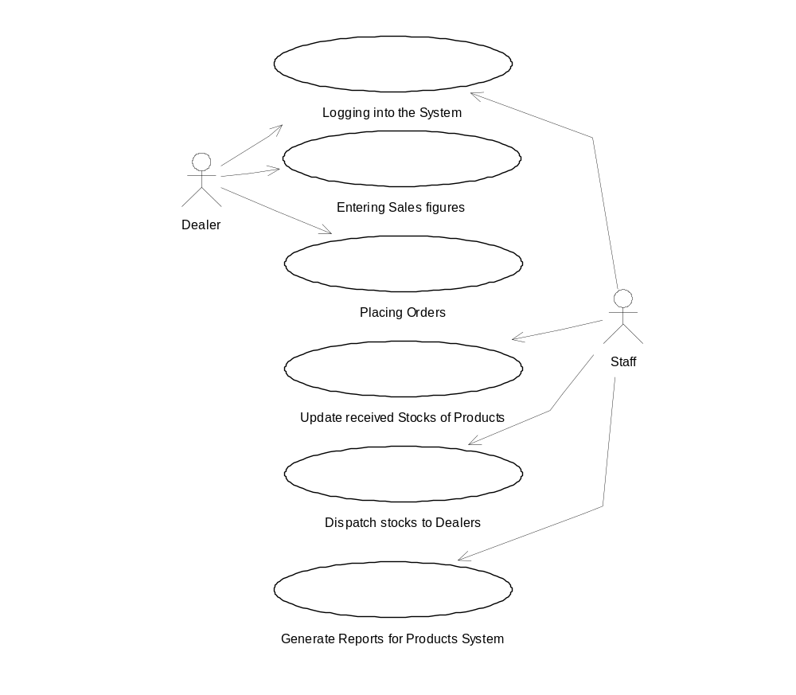
7. Generate the Parts Indent
8. Send requests to Suppliers for Quotations
9. Suppliers submit Quotations
10. Staff confirm order for Supply of Parts
11. Update Part stocks received from Suppliers
12. Update Part stocks delivered to Production Department

The Use Case diagram depicting the above Use cases & the Actors involved is shown below: 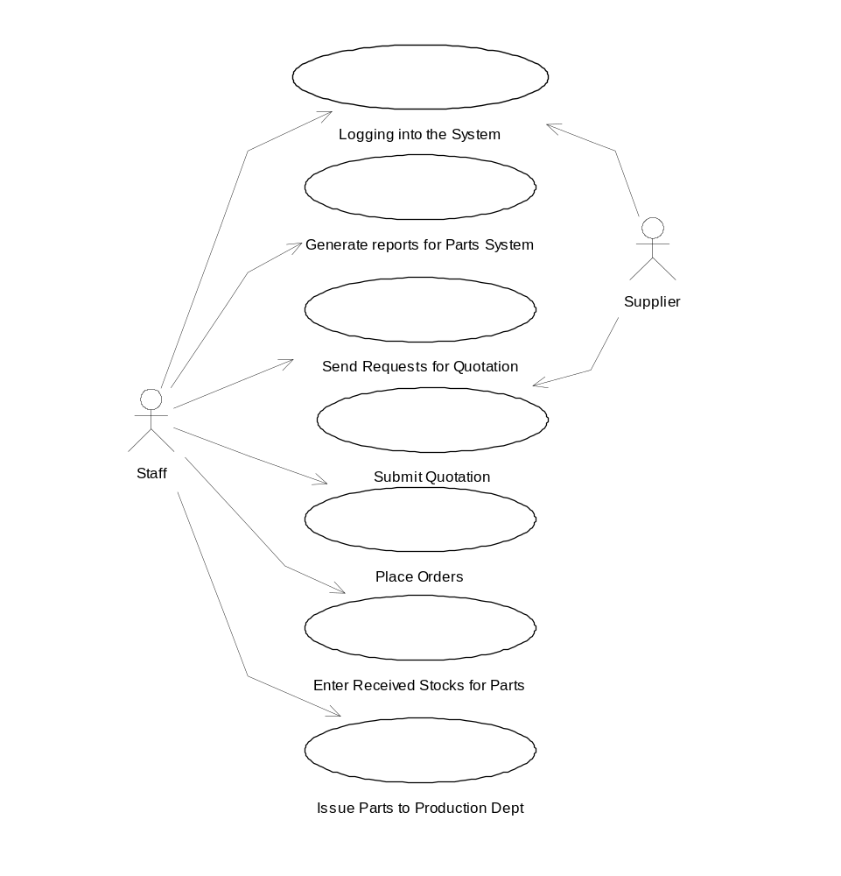

13. Add / Modify / Delete Dealers
14. Add / Modify / Delete Products
15. Add / Modify / Delete Parts
16. Add / Modify / Delete Suppliers
17. Add / Modify / Delete Users
18. Add / Modify / Delete Bill-of-Materials
19. Log out of the system

The Use Case diagram depicting the above Use cases & the Actors involved is shown below:
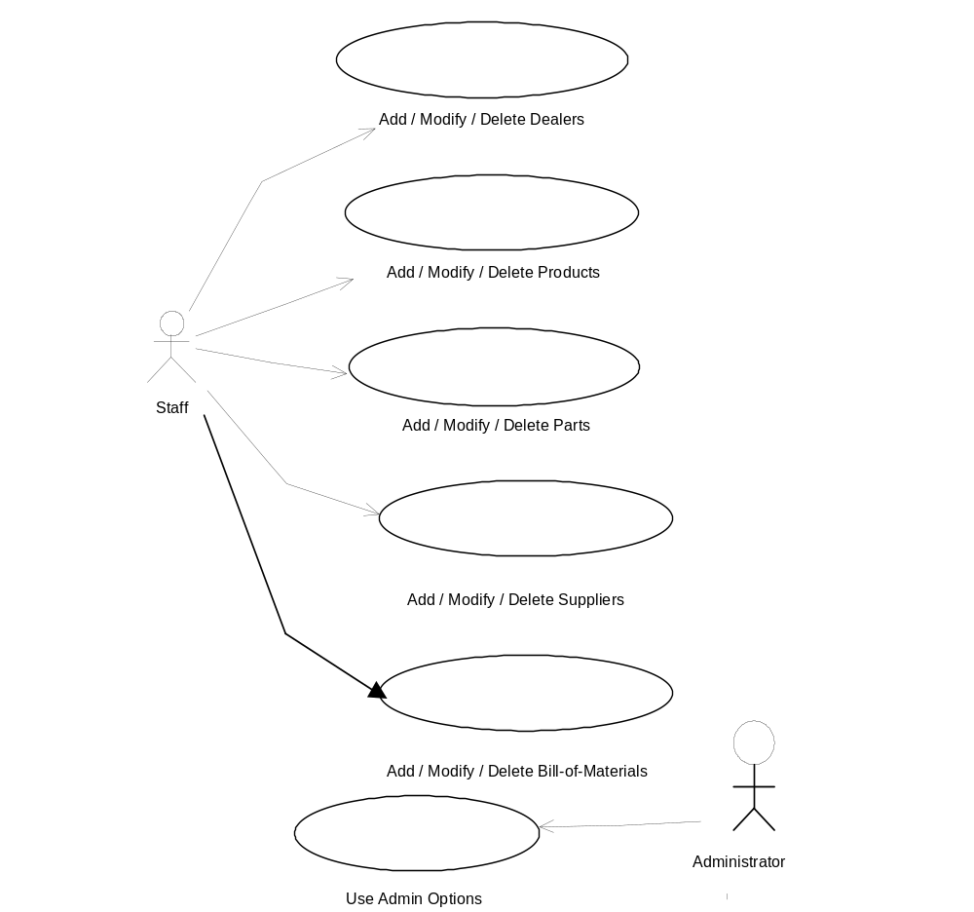
Thus the system is divided into loosely coupled sub-systems as detailed below.

The First Sub-system :

- The System stores the Stock details of finished Products held with the Company.
- The System stores the details of all the Dealers.
- The System stores the details of the finished products (henceforth called Products) held with the Dealers.
- The daily Sales figures of the Products are used to update the details of the products with the dealers.
- The System stores the Orders for Products from the Dealers.
- A “Production Schedule” is generated for the Production Department based on the Orders placed & current stocks of finished Products held with the Company.
- Once finished Products are received from the Production Department, the stocks of finished Products with the Company are updated.
- If an Order is dispatched, the Stocks held with the Company are updated (remove the dispatched stocks from the stock held) & the Order status is changed as delivered. This also updates the Stocks held with the Dealers.

The Second Sub-system :

- The System stores the Stock details of Raw Materials held with the Company.
- The System stores the details of all the Suppliers.
- The System stores the rates quoted by the Suppliers for each Raw Material or Part required for Production.
- The System stores the Bill-Of-Materials for each Product, which is used to calculate the Raw Materials required for the Production Schedule.
- The daily figures of the consumed Raw Materials that are issued to the Production Department are used to update the details of the Raw Material held with the Company.
- Based on the “Production Schedule” passed by the first sub-system, a “Parts Indent or Requirements Order” is generated for Ordering the Raw Materials required from the Suppliers.
- Based on the “Requirements Order Report” passed on by the First Sub-system, a “Quotations intimation” is generated & is sent to the Registered Suppliers as email message.
- The System provides for the Suppliers to quote their rates online using their Login & Passwords.
- From the quotations a Report is generated showing all the Quotations. This Report has an option, which enables the Staff to Confirm the Order to the Suppliers.
- If confirmed an email is sent to the Suppliers with the Details & the status of the requirement is changed to reflect the order confirmation.
- An option is provided to generate an Event, which informs the Administrator about the Order details if it is not the lowest Quotation.
- Once Raw Materials are received from the Suppliers, the stocks of Raw Materials with the Company are updated & the Order status is changed as Received.
- If Raw Materials are issued to the Production Department, the Stocks held with the Company are updated (remove the issued stocks from the stock held).

Analysis of each Use Case

Logging into the System:

The User (either the Staff, or the Dealer or the Supplier) logs into the System by entering their Usernames & Passwords. The Usernames & Passwords are authenticated, by checking the database. Once an authorized User enters the System, the options available to him are shown in a Menu. He has to choose the required options.

Enter Sales Figures by the Dealers:

The Dealer has an option to enter the sales figures for a given period of time. It is assumed that the figures are entered weekly. The Dealer has to enter the Product code & the quantity that has been sold during the week. Once these are entered he is taken to the Place Orders option.

Placing Orders for Products by the Dealers:

At the outset there is an option to Place the Order, which is equal to the Sales figure entered. If this is not chosen, then an option to enter the Orders will be shown. The Dealer has to place the Orders required. Then the sales figures are used to update the Stocks of Products of the dealers & Orders placed are added to the Orders Table.

Update Received Stocks of Products from Production Dept.:

The staff have an option to update the Stocks of the Products held by the Company when they receive finished Products from the Production Department. They enter the figures of the Products received from the Production Dept..

Dispatch Stocks to Dealers:

The staff have an option to update the Stock held with the company & the Dealers Stocks whenever any Dispatch of the Products is made. The stock held with the company is updated by removing the figures of Products dispatched to a Dealer & the same figures are added to the Dealers stock quantities.

Generate Production Schedule Report:

Generate the Production Schedule Report from the Products System. This is made available to the Parts System. This report generates the list of Products to be ordered based on the current stocks of Products held with the company.

Generate Parts Indent:

Generate the Parts Indent or Requirements Report from the Production Schedule. This report is generated, by taking into consideration the currently available Stocks of Parts already held with the company.

Send requests to Suppliers for Quotations:

The above Report is used to send Requests for Quotations to the Suppliers. If there is a Parts Indent whose status is “required”, then the Suppliers will be intimated to Quote their rates.

Suppliers Submit Quotations:

The Suppliers then login and are shown the list of requirements for the parts. They can quote the rates online. These rates are then stored in the database.

Staff confirm order for Supply of Parts:

The Staff can then confirm the orders for the parts. If the rates are not quoted, the latest quoted rates for all suppliers whose Status is active is retrieved. The staff send intimation that an Order was confirmed with the Suppliers. If the rates quoted are not for the lowest bids, an event is generated which intimates the Higher-authority like the Admin is intimated about the Parts ordered.

Update Part stocks received from Suppliers:

The staff has an option to update the Stocks of the Parts held by the Company when, they are delivered by the Suppliers. This option is available to the Company Staff only.

Update Part stocks delivered to Production Department:

The Company staff have an option to update the Stock of Parts held with the company whenever any Issue of the Parts is made to the Production Department. The stock held with the company is updated by removing the figures of Parts issued to the Production Department.

Add / Modify / Delete Dealers

The Company staff have an option to add or modify or delete Dealers details. Whenever a new Dealer is added to the company network, he is assigned a unique dealer id & details like Dealer Name, Address, Credit limit, Status are stored in the system. An option is provided to modify or delete any Dealer’s details.

Add / Modify / Delete Products

Whenever the manufacture of a new Product is taken up by the company, it is assigned a unique Product id. Details like the Name, Description, Price & Status of the Product are stored. The company staff have an option to modify or delete the details of any Product thus entered into the system.

Add / Modify / Delete Parts

Whenever a new Part is required for the manufacture of a Product, it is assigned a unique Part id. Details like the Name, Description, Quantity & Status of the Part are stored. The company staff have an option to modify or delete the details of any Part thus entered into the system.

Add / Modify / Delete Bill-of-Materials

Whenever a new Product is taken up for Production, a Bill-of-Materials is created for it. The Bill-of-Materials contains the details for the Product Id & every Part id & the number of Parts that are required for the manufacture of one Product. This table is used to calculate the total type & quantity of Parts required for the manufacture of each product. The Company Staff have an option to add / modify / delete a Bill-of-Materials for every Product.

Add / Modify / Delete Suppliers

The Company staff have an option to add or modify or delete Suppliers details. Whenever a new Supplier is added to the company network, he is assigned a unique Supplier id & details like Supplier Name, Address, & Status are stored in the system. An option is provided to modify or delete any Supplier’s details.

Add / Modify / Delete Users

The Company staff have an option to add or modify or delete Dealers/Suppliers staff as Users of the system. Whenever a new User is added to the company network, he is assigned a unique User Login Name & details like Dealer Id/Supplier id, password, & login type are stored in the system. An option is provided to modify or delete any User’s details.

4.4 Analysis Models & Analysis Classes for the Use Cases

The analysis model further specifies the use cases. A use-case realization is depicted as a collaboration between various classes that are identified from the textual description of the use cases [USDP-2000]. Thus the following Models yield the Analysis classes listed after each model.

Logging into the System:

The Figure below shows an analysis model for the Logging into the System use case.

User
User
Interface
Validate Logging into the System
User Details
Logging into the System
Logging into the System
<<trace>>
Analysis model for Logging into the System use-case

Use-Case Model
Analysis Model

From the above Figure, the notation for a use case realization is an ellipse with a dashed line. The stereotype <<trace>> indicates a dependency between the use case and its realization. The analysis classes are also annotated with stereotypes. The circles with various adornments are different types of classes: User and User Interface are known as Boundary classes since they are used to model interaction between the system and its actors. Validate logging into the System is a control class that is used to represent co-ordination and sequencing of other objects, and is used to encapsulate control related to a specific use case. User Details is an entity class that is used to model persistent information.

Enter Sales Figures by the Dealers:

The Figure below shows an analysis model Entering the Sales figures by Dealers use case.

Dealer
Dealer
Interface
Validate Sales Figures
Dealer Stock Details
Enter Sales Figures by the Dealers
Enter Sales Figures by the Dealers
<<trace>>
Analysis model for Enter Sales Figures by the Dealersuse-case

Use-Case Model
Analysis Model

Boundary classes – Dealer and Dealer Interface
Control class – Validate Sales figures
Entity class – Dealer Stock Details

Placing Orders for Products by the Dealers:

Dealer
Dealer
Interface
Validate Orders
Dealer Order Details
Placing Orders for Products by the Dealers
Placing Orders for Products by the Dealers
<<trace>>
Analysis model for Placing Orders for Products by the Dealersuse-case

Use-Case Model
Analysis Model

Boundary classes – Dealer and Dealer Interface
Control class – Validate Orders
Entity class – Dealer Order Details

Update Received Stocks of Products from Production Dept.:

Analysis model for Updating Received Stocks of Products from Production Dept. use-case

Use-Case Model
Analysis Model

<<trace>>

Updating Received Stocks of Products from Production Dept

Update Received Stocks of Products from Production Dept

Staff
Interface

Staff
Validate Stocks Received
Company Product Stock Details

Boundary classes – Staff and Staff Interface
Control class – Validate Stocks received
Entity class – Company product Stock Details
Dispatch Stocks to Dealers

Analysis model for Dispatch Stocks to Dealers use-case

Use-Case Model
Analysis Model

<<trace>>

Dispatch Stocks to Dealers

Dispatch Stocks to Dealers

Staff
Interface

Staff
Validate Stocks Dispatched
Company Product Stock Details

Boundary classes – Staff and Staff Interface
Control class – Validate Stocks received
Entity class – Company product Stock Details, Dealer Product Stock
Dealer Product Stock Details
Details

Generate Production Schedule Report:

Analysis model for Generate Production Schedule Report use-case

Use-Case Model
Analysis Model

<<trace>>

Generate Production Schedule Report

Generate Production Schedule Report

Staff
Interface

Staff
Calculate Product Stocks Required
Company Product Stock Details

Boundary classes – Staff and Staff Interface
Control class - Calculate Product Stocks required
Entity class – Company product Stock Details, Dealer Order Details
Dealer Order Details
Generate Parts Indent:

Analysis model for Generate Parts Indent use-case

Use-Case Model
Analysis Model

<<trace>>

Generate Parts Indent

Generate Parts Indent

Staff
Interface

Staff
Calculate Part Stocks Required
Company Part Stock Details

Boundary classes – Staff and Staff Interface
Control class – Calculate Part Stocks required
Entity class – Company product Stock Details, Production Schedule
Production Schedule Details
Details
Send requests to Suppliers for Quotations

Analysis model for Send requests to Suppliers for Quotations Use-case

Use-Case Model
Analysis Model

<<trace>>

Send requests to Suppliers for Quotations

Send requests to Suppliers for Quotations

Staff
Interface

Staff
Send requests for Quotations
Parts Indent

Boundary classes – Staff and Staff Interface
Control class – Send requests for Quotations
Entity class – Parts Indent, Supplier details
Supplier Details

Suppliers Submit Quotations

Analysis model for Suppliers Submit Quotations Use-case

Use-Case Model
Analysis Model

<<trace>>

Suppliers Submit Quotations

Suppliers Submit Quotations

Supplier
Interface

Supplier
Submit Quotations
Parts Indent

Boundary classes – Supplier and Supplier Interface
Control class – Submit Quotations
Entity class – Parts Indent, Supplier details
Supplier Details

Staff confirm order for Supply of Parts

Analysis model for Staff confirm order for Supply of Parts Use-case

Use-Case Model
Analysis Model

<<trace>>

Staff confirm order for Supply of Parts

Staff confirm order for Supply of Parts

Staff
Interface

Staff
Confirm Orders for Parts and intimate admin
Parts Indent

Boundary classes – Staff and Staff Interface
Control class – Confirm Orders for Parts and intimate admin
Entity class – Parts Indent, Supplier details
Supplier Details

Update Part stocks received from Suppliers

Analysis model for Update Part stocks received from Suppliers Use-case

Use-Case Model
Analysis Model

<<trace>>

Update Part stocks received from Suppliers

Update Part stocks received from Suppliers

Staff
Interface

Staff
Update Part stocks received from Suppliers
Company Part Stocks Details

Boundary classes – Staff and Staff Interface
Control class – Update Part stocks received from Suppliers
Entity class – Company Part Stocks details, Supplier details
Supplier Details

Update Part stocks delivered to Production Department

Analysis model for Update Part stocks delivered to Production Department Use-case

Use-Case Model
Analysis Model

<<trace>>

Update Part stocks delivered to Production Department

Update Part stocks delivered to Production Department

Staff
Interface

Staff
Update Part stocks delivered to Production Department
Company Part Stocks Details

Boundary classes – Staff and Staff Interface
Control class – Update Part stocks delivered to Production Department
Entity class – Company Part Stocks details

Add / Modify / Delete Dealers

Analysis model for Add / Modify / Delete Dealers Use-case

Use-Case Model
Analysis Model

<<trace>>

Add / Modify / Delete Dealers

Add / Modify / Delete Dealers

Staff
Interface

Staff

Add / Modify / Delete Dealers

Dealer Details

Boundary classes – Staff and Staff Interface

Control class – Add / Modify / Delete Dealers
Entity class – Dealer details

Add / Modify / Delete Products:

Analysis model for Add / Modify / Delete Products Use-case

Use-Case Model
Analysis Model

<<trace>>

Add / Modify / Delete Products

Add / Modify / Delete Products

Staff
Interface

Staff

Add / Modify / Delete Products

Product Details

Boundary classes – Staff and Staff Interface

Control class – Add / Modify / Delete Products
Entity class – Product details

Add / Modify / Delete Parts

Analysis model for Add / Modify / Delete Parts Use-case

Use-Case Model
Analysis Model

<<trace>>

Add / Modify / Delete Parts

Add / Modify / Delete Parts

Staff
Interface

Staff

Add / Modify / Delete Parts

Part Details

Boundary classes – Staff and Staff Interface

Control class – Add / Modify / Delete Parts
Entity class – Part details

Add / Modify / Delete Bill-of-Materials

Analysis model for Add / Modify / Delete Bill-of-Materials Use-case

Use-Case Model
Analysis Model

<<trace>>

Add / Modify / Delete Bill-of-Materials

Add / Modify / Delete Bill-of-Materials

Staff
Interface

Staff

Add / Modify / Delete Bill-of-Materials

Part Details

Boundary classes – Staff and Staff Interface

Control class – Add / Modify / Delete Bill-of-Materials
Entity class – Part details, Product Details, Bill-of-Materials
Product Details
Details
Bill-of-Materials Details
Add / Modify / Delete Suppliers

Analysis model for Add / Modify / Delete Suppliers Use-case

Use-Case Model
Analysis Model

<<trace>>

Add / Modify / Delete Suppliers

Add / Modify / Delete Suppliers

Staff
Interface

Staff

Add / Modify / Delete Suppliers

Supplier Details

Boundary classes – Staff and Staff Interface

Control class – Add / Modify / Delete Suppliers
Entity class – Supplier details

Add / Modify / Delete Users

Analysis model for Add / Modify / Delete Users Use-case

Use-Case Model
Analysis Model

<<trace>>

Add / Modify / Delete Users

Add / Modify / Delete Users

Staff
Interface

Staff

Add / Modify / Delete Users

User Details

Boundary classes – Staff and Staff Interface

Control class – Add / Modify / Delete Users
Entity class – User details

Chapter 5 - Design of the System

  - Introduction

The design model is created from the analysis model. The classes in the Analysis model are revised to take into account the specifics of the implementation environment. They are refined to design classes that specify the requirements of the implementation in more detail[USDP-2000]. For example the User Interface analysis class could be traced to the following design classes: ValidatePassword, CreateMenuOptions, and User Manager. The other analysis classes have their own corresponding design classes. Essentially, a set of design classes is the realizable version of a corresponding conceptual analysis class.

Since J2EE is chosen as the Architecture, the Client Tier is developed in Servlets / JavaScript. The middle tier is designed in Java Classes the back-end is a relational Database.

5.2 Sequence Diagrams

From the Analysis models derived from the Use-cases, sequence diagrams for each Use-case are developed. Sequence diagrams show how the focus moves from object to object as the use case is performed. The objects involved in the use case ralisation are shown at the top, arrows between them are messages. The receiving object takes over the focus from the sender. A lot of detail yet to be specified in the analysis model, is revealed in the design model.

Sequence diagram for Logging into the System:

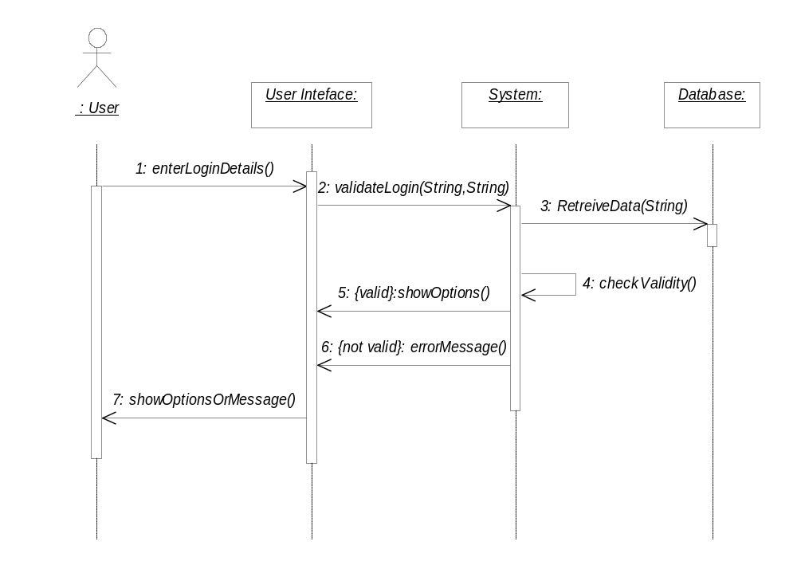

Sequence Diagram for Entering Sales figures by the Dealers:

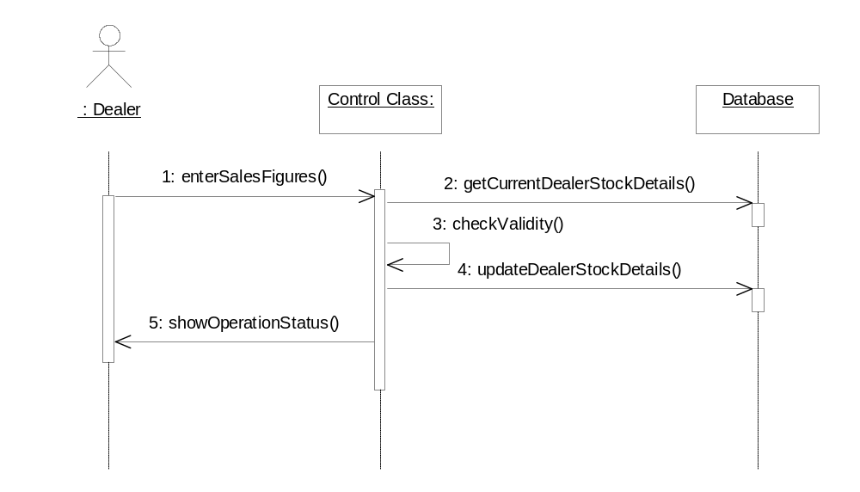

Sequence Diagram for Placing Orders for Products by the Dealers
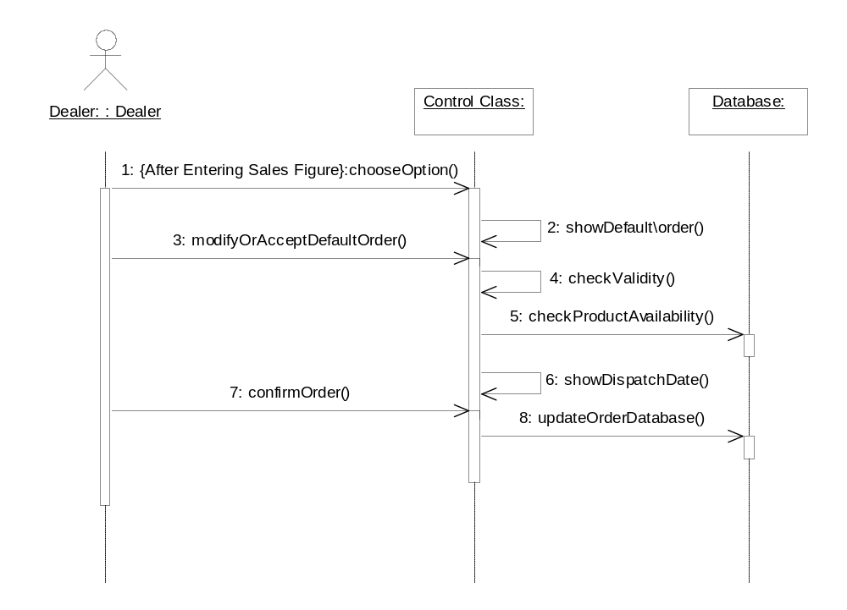
Sequence Diagram for Update received stocks of Products:

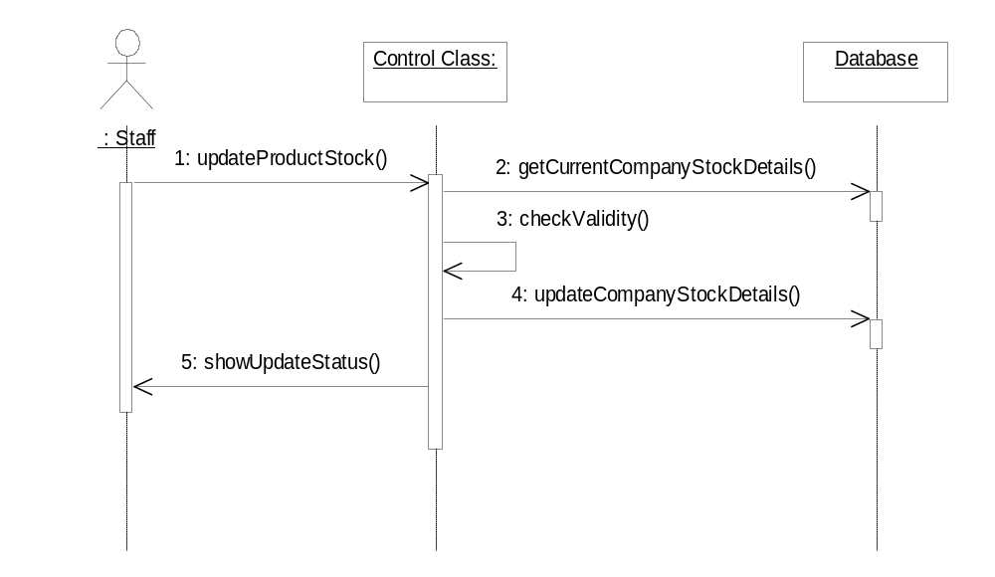

Sequence Diagram for Dispatch stocks to Dealers
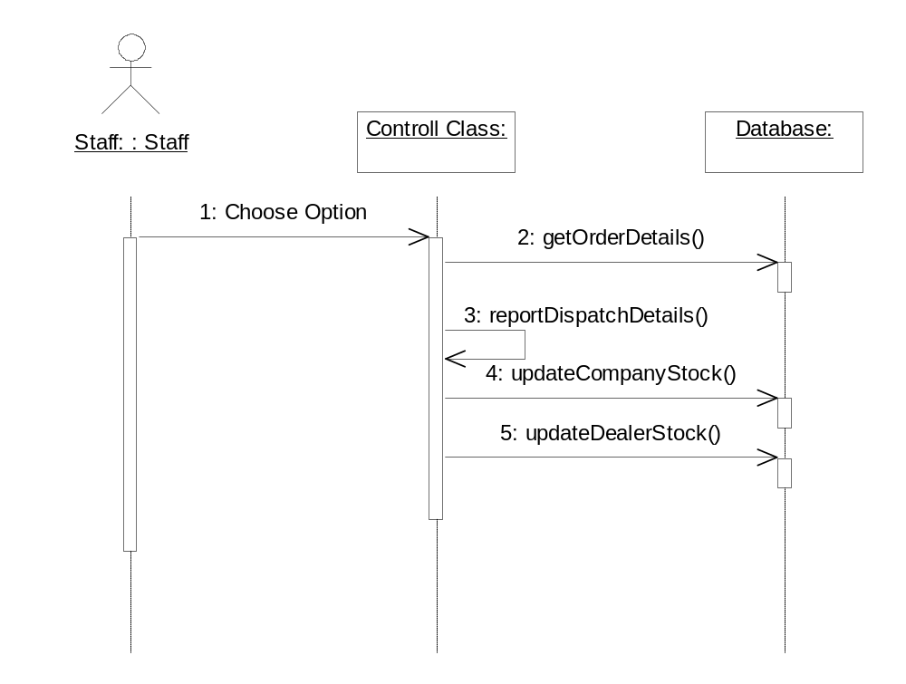
Sequence Diagram for Generate the Production Schedule report & Parts Indent

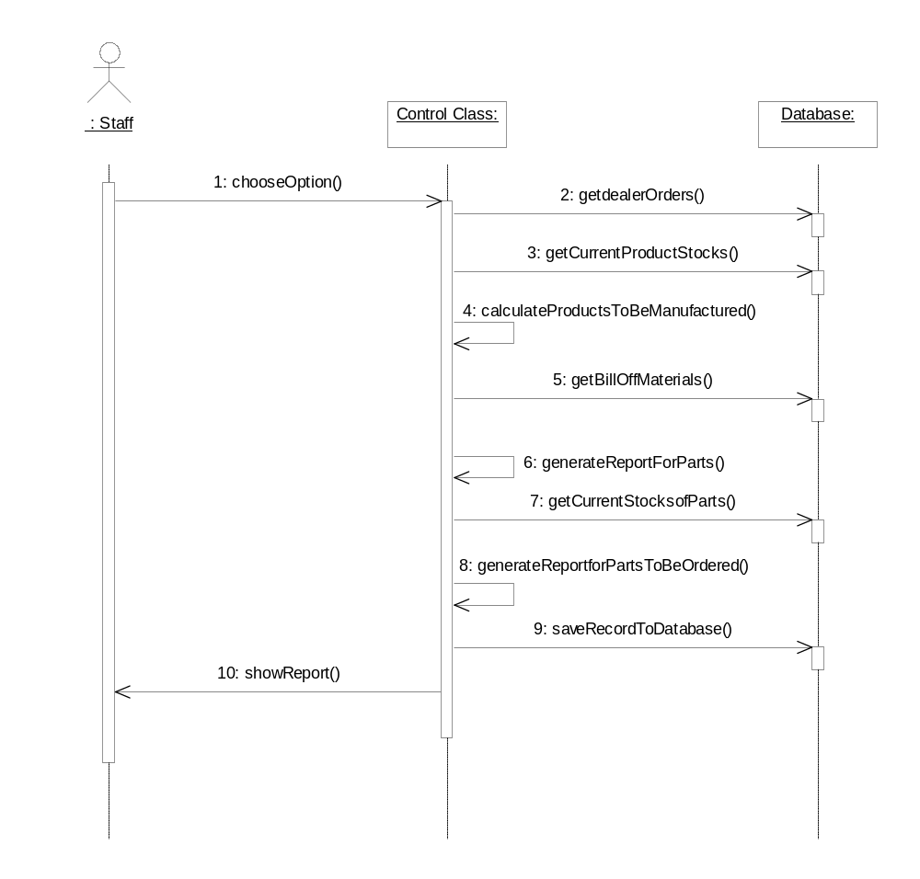
Sequence Diagram for Send requests to Suppliers for Quotations

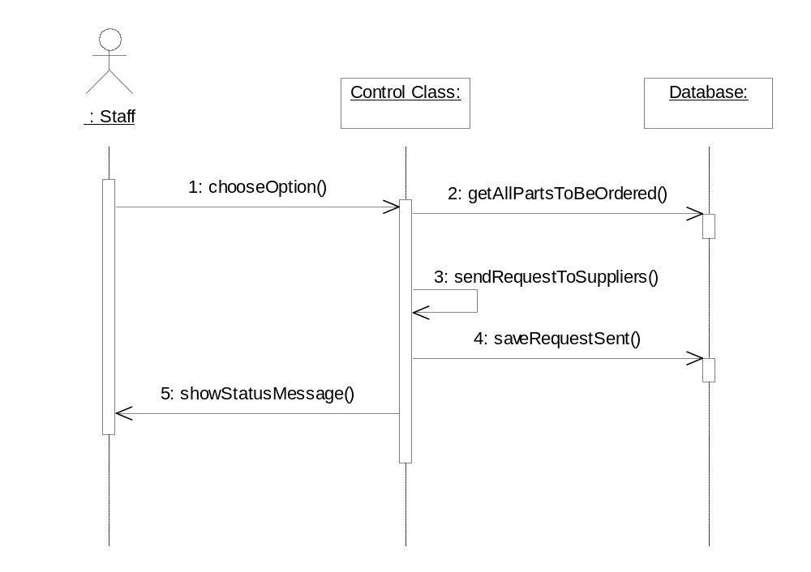
Sequence Diagram for Suppliers submit Quotations
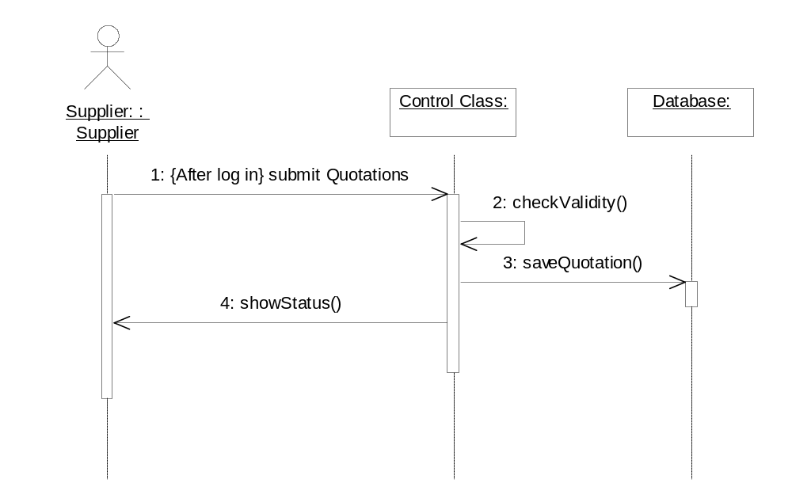
Sequence Diagram for Staff confirm order for Supply of Parts 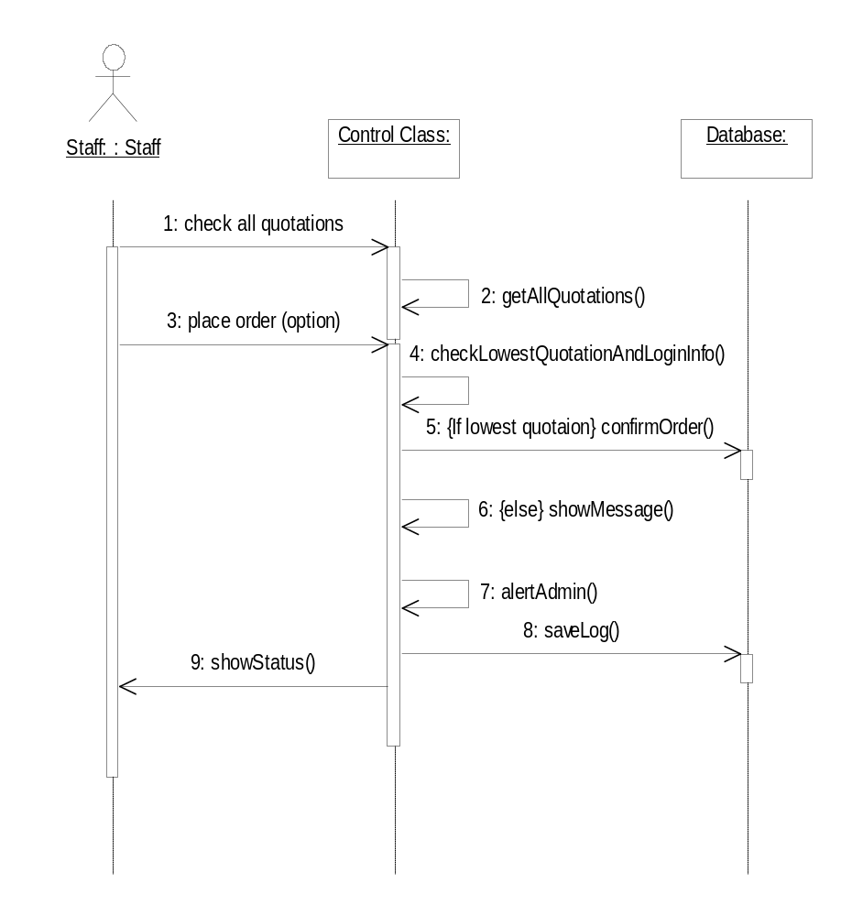

Sequence Diagram for Update Part stocks received from Suppliers

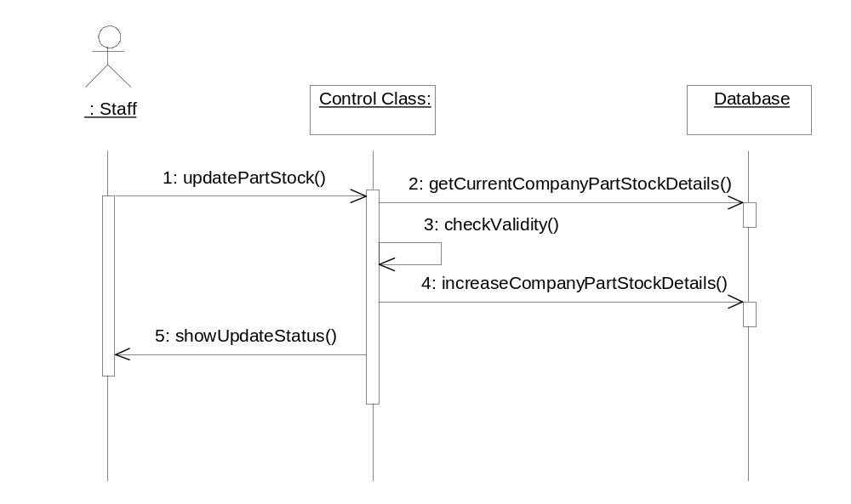

Sequence Diagram for Update Part stocks delivered to Production Department

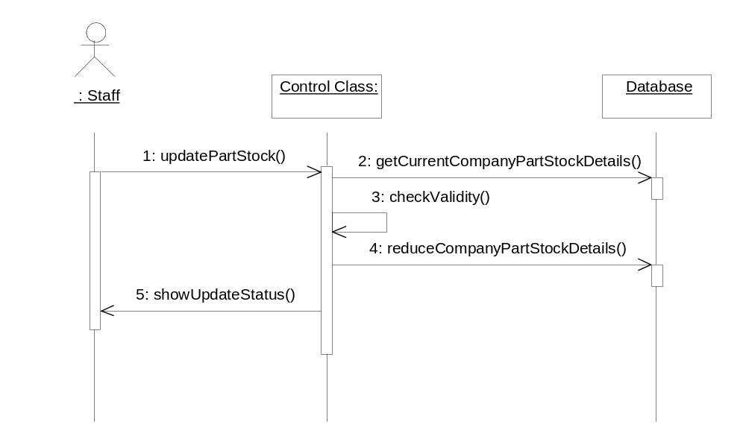
Sequence Diagram for Add Dealers / Products / Parts / Suppliers / Users / Bill-of-Materials

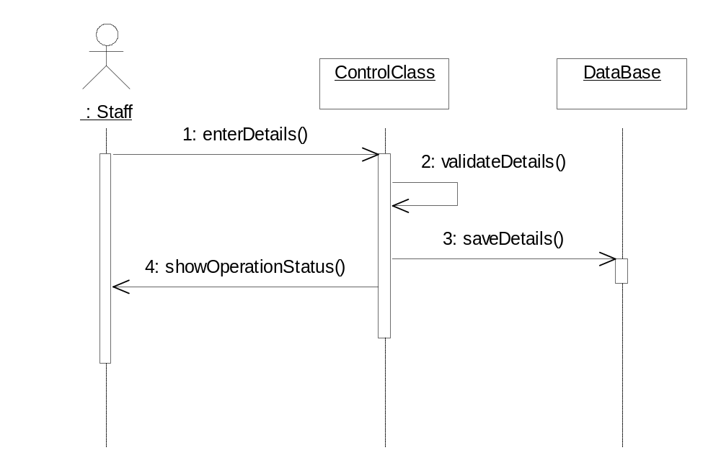

Sequence Diagram for Modify Dealers / Products / Parts / Suppliers / Users / Bill-of-Materials
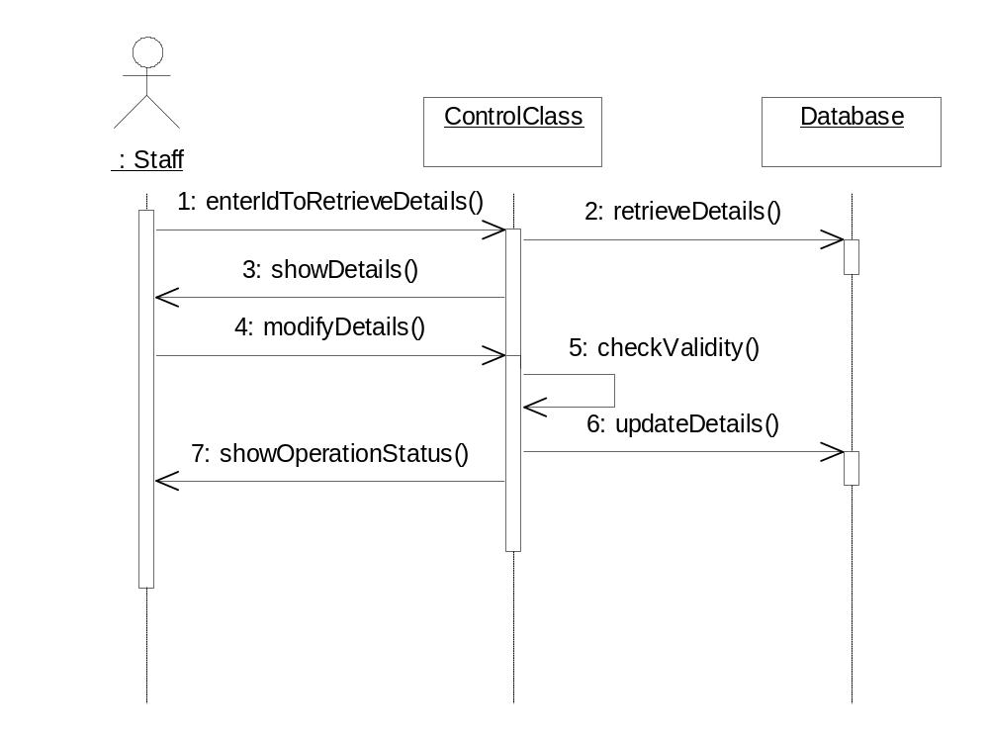
Sequence Diagram for Delete Dealers / Products / Parts / Suppliers / Users / Bill-of-Materials

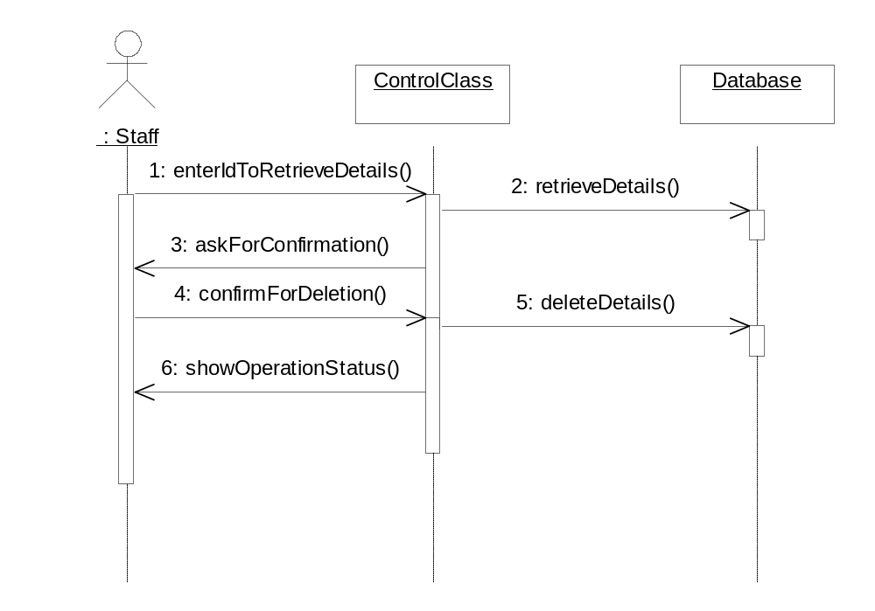
5.3.2 Class Diagrams

A high level class diagram representing the interactions among the different Beans, a class diagram for the Dealer Entity Bean, a DealerSF Session Bean & the Class diagram where JSPs interact with Entity Beans are shown below:

High level Class Diagram of all the Enterprise Java Beans :
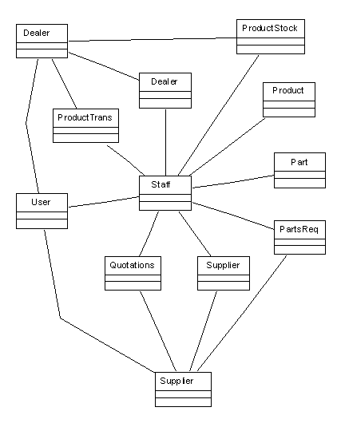

Similarly foreign Key Constraints are created in the database to maintain the integrity of the database. For example the following figure shows the foreign key relationships in the database. The following figure gives the outline ERD of the Tables in the system.

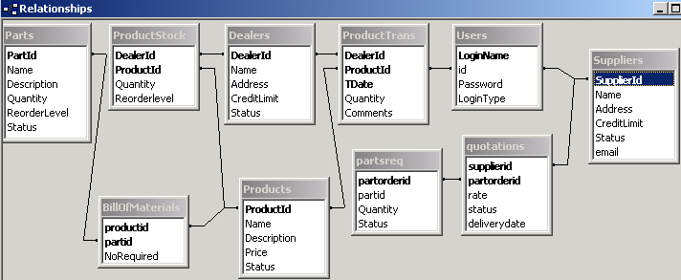

These foreign key constraints ensure that the data in the database remains valid.

